Case

Studies for

Power

BI

**1. Operational Process Improvement for a group of dental hospitals**

# The Challenge

The client wanted to improve their operational processes to make use of Power BI reports to identify the pitfalls of the processes, take steps to overcome the pitfalls identified in order to maximize their revenue. They also wanted to capture certain traits related to patients, such as which topographical region showed most patients.

# The Solution

We developed a bunch of reports related to their assessment process. Questions like, Who did the initial assessment, intern, doctor or specialist? Was there a necessity to refer patient to a specialist? How many more assessments were required for a patient? We helped them infer an assessment index based on the above information. This traits of this index helped them identify where they were lacking in their assessment process and they improved it to a considerable level. Also, they could now predict when and how many interns to hire.

Other most import factor was treatment. We developed the reports that helped them study the treatment process. This included analysing the following parameters,

* What was the diagnosis made?
* What treatments were incorporated?
* What medications were involved?
* What were the instruments required for the treatment?
* How many patients were allergic to the treatments?
* What number of patients were in what stage of medical condition?

We helped them infer several treatment indexes by converting the information we captured into various quick-to-infer charts and graphs. These indexes led them to improve their diagnosis capabilities, identify what training to provide to interns and doctors, what medicines to use and keep an appropriate number of instruments in the hospital.

Several other reports, such as a map showing topography of the patients, regularity of employees, year-year and quarter-quarter revenue, branch wise revenue etc. were also developed.

# A glimpse of reporting

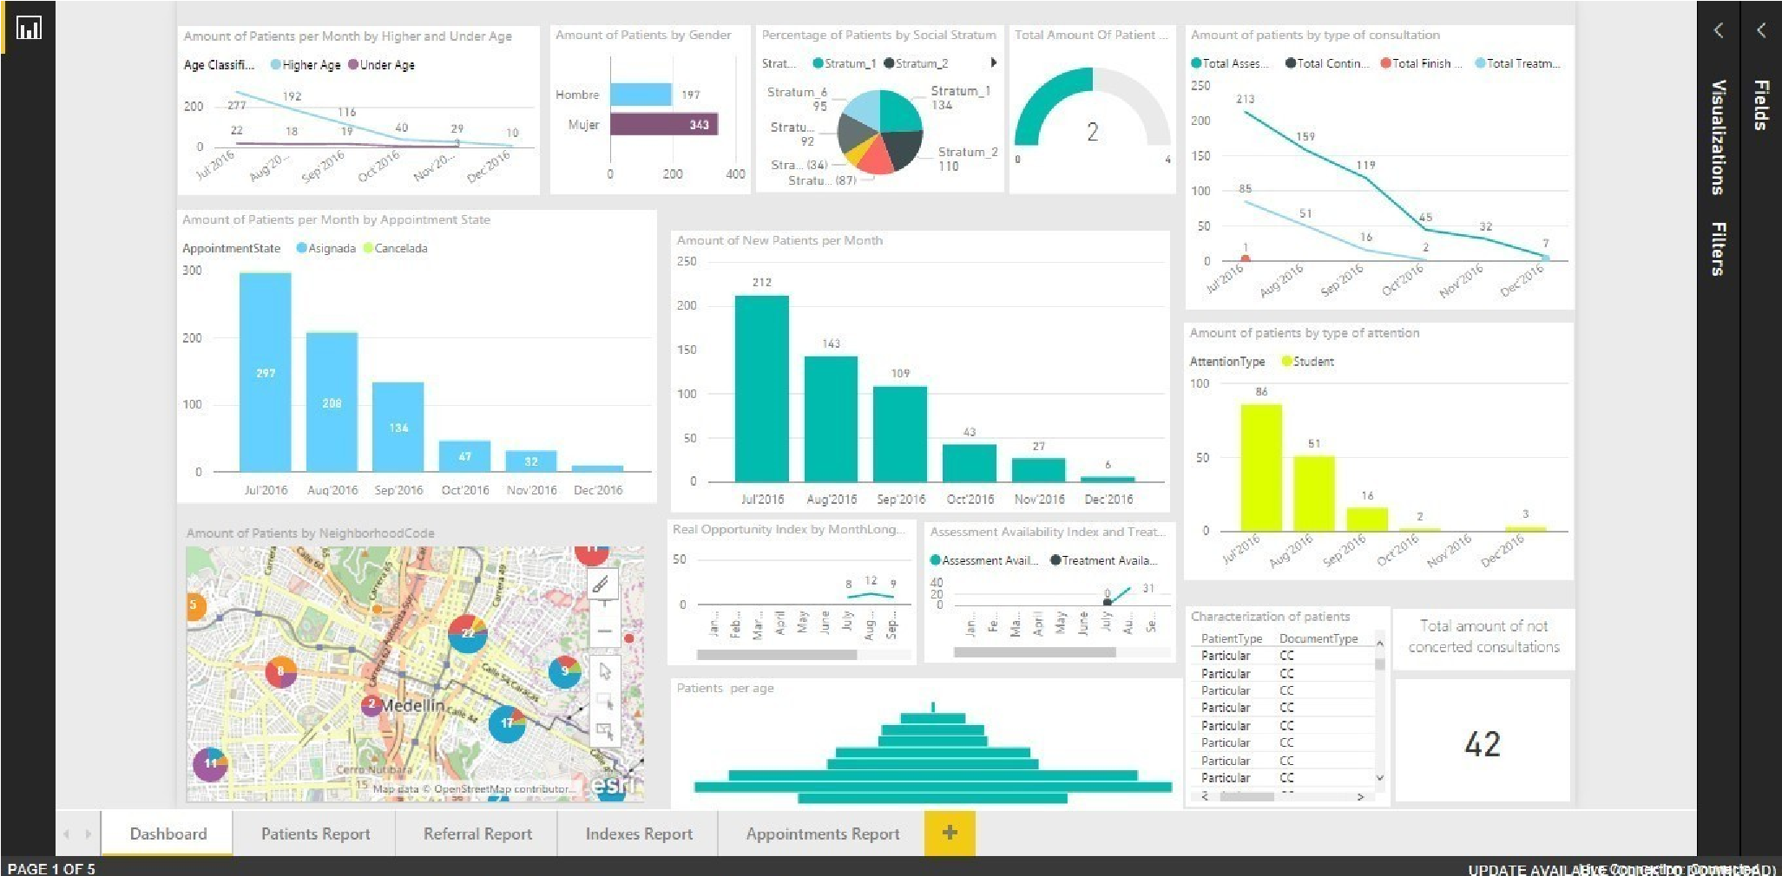

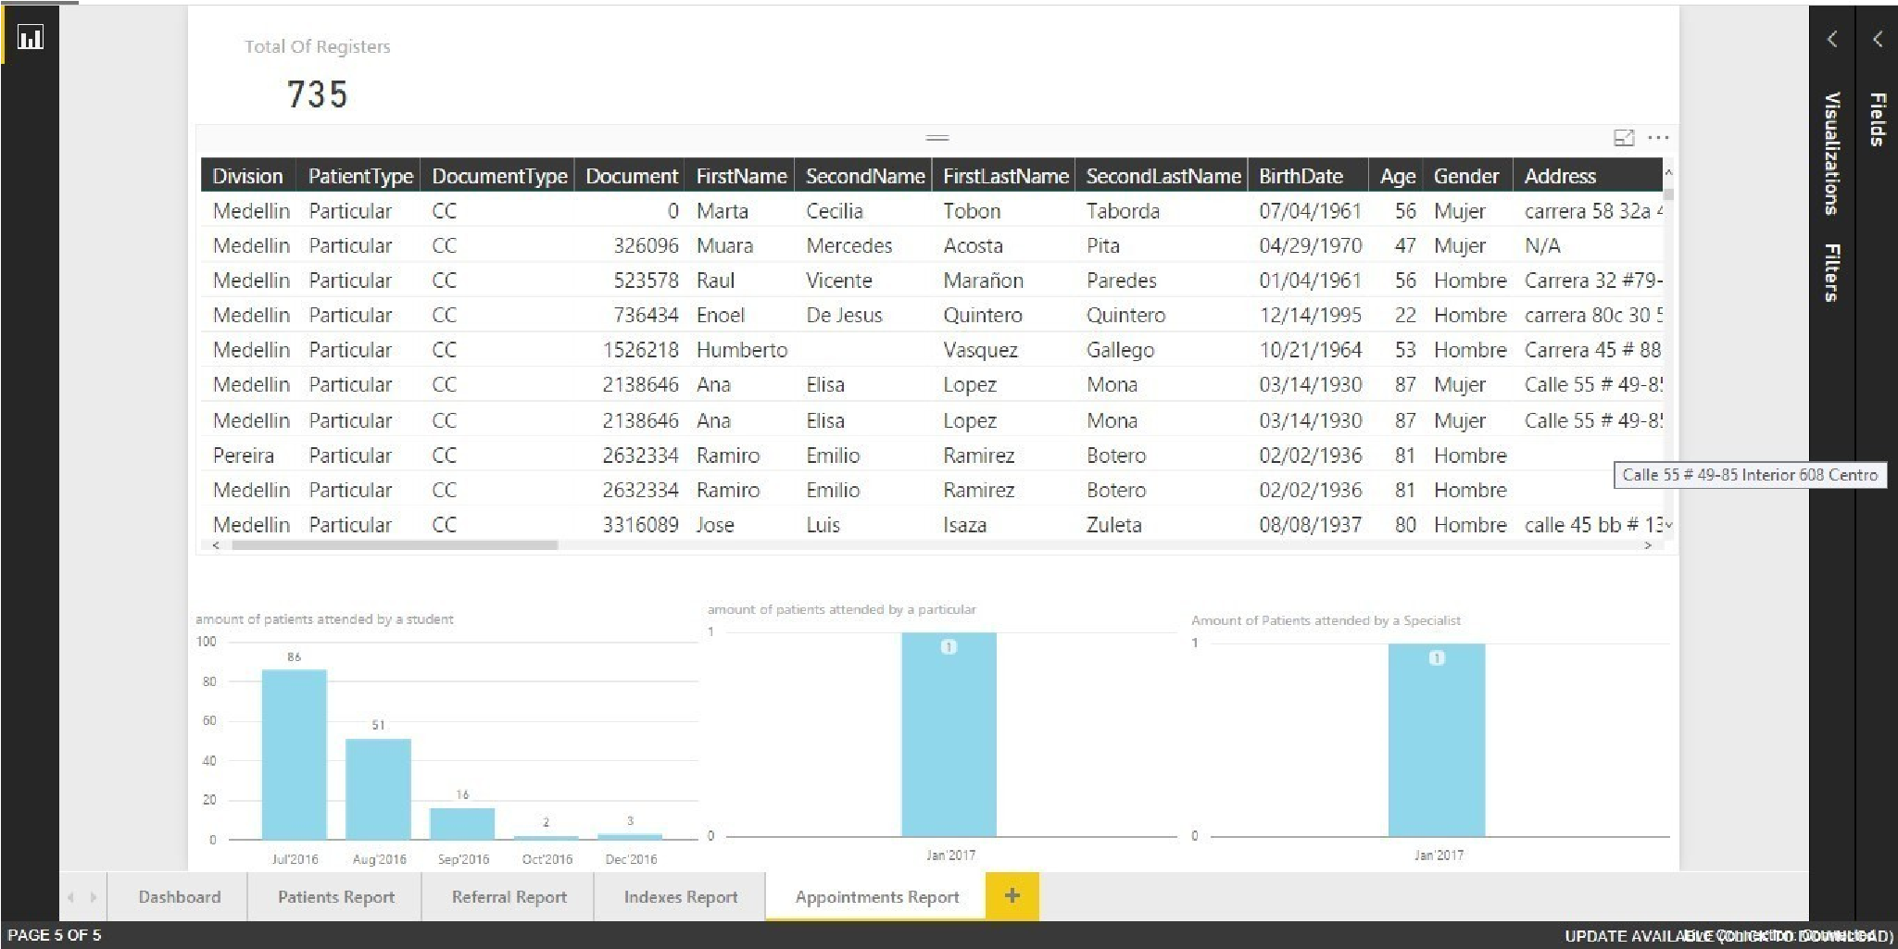

**2. Helping HR in recruitment process**

# The Challenge

Our client used to follow a manual paper-work based recruitment process. He had to manage a lot of data in excel sheets. The process was tedious and error prone. On the top of that, they could not afford to spend time in manually analysing the valuable information they captured. As they assigned us the task move towards shifting to new technologies and automating the data capturing and analysing process, they also wanted us to develop useful reports which would help them predict future trends.

# The Solution

To keep the automation process in line with other tools used by the client, we suggested them to go with Power BI for reporting purpose.

We developed a number of reports for them. The visuals used were eye catching. The reports were easy enough to understand and even a lay man could grasp useful information by just a glance at a report. The reports contained useful indicators like total recruitment over time and average CTC offered to & is expected by the candidates. All the reports contained default filters like period (Apr 2016 - Mar 2017). We also provided a separate report that allowed to compare candidates based on the aspects like salary, qualification and experience. Drill down reports were included whenever required.

The client could now easily get to know top 10 sources of recruitment and top 10 reasons that made the candidates leave their previous company. The same data helped them to modify their existing policies and reduce employee attrition rate. They could now forecast a lower limit of written test score for selecting candidates. Number of reports included trends built up from the information. Trends like the salary expectations a certain experience level with a specific technical expertise helped then a lot in deciding the annual salary hike of their existing employees. Now they also have numbers of candidates who were expert in a specific technology. And the list of benefits goes on.

The client is more than satisfied with the ease of use and value of information they can capture using Power BI.

We tried to decipher the data and tried to come up with the ideas that will be helpful to the organization:

* Information of the candidates that are applying/appearing/not appearing/selected/joined for the interview.
* Information about the sources that has helped the candidates to apply for interview.
* Information about last companies that the applied candidates were working at.
* Details of the candidates by their expertise when appeared in an interview **●** Which are the top 10 sources that candidates have found the organization?
* Which were the top 10 reasons for the candidates to leave their last company?
* Information about the hired candidates and their experience.
* Information about the scores by their quality and their experience.
* Information about the notice period by their experience.

# The Extra Mile

* Information about the CTC by their experience and their expertise (technology).
* Trends of CTC by their Expertise and hike according to their experience.
* Forecast of CTC by their Expertise and hike according to their experience.
* Information about the time that the candidates are ready to commit.

# A glimpse of reporting

